Volunteer for Troy Peer Court

Learn firsthand how the judicial process works
Help your errant peers repair harm they have done
Help keep youth out of the criminal justice system
Have a positive impact on your community
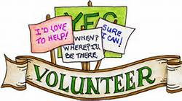

To sign up or if you have any questions, please contact Troy Police Officers Colleen Goldston or Aaron Collington at
270-4689 or see your School Resource Officer

